1️⃣ Flask API returning JSON data
Task:
Create a Flask application with an /api route that returns data stored in a backend JSON file.

Commands and Code:
mkdir flask_MongoDB
cd flask_MongoDB
pip install flask
# app.py
from flask import Flask, jsonify
import json

app = Flask(__name__)

@app.route('/api', methods=['GET'])
def get_data():
with open('data.json', 'r') as file:
data = json.load(file)
return jsonify(data)

if __name__ == '__main__':
app.run(debug=True)

Explanation:
This Flask app reads data from a local data.json file and returns it as a JSON response when /api is accessed.
When you open http://127.0.0.1:5000/api in a browser, the JSON data is displayed.

Screenshots:
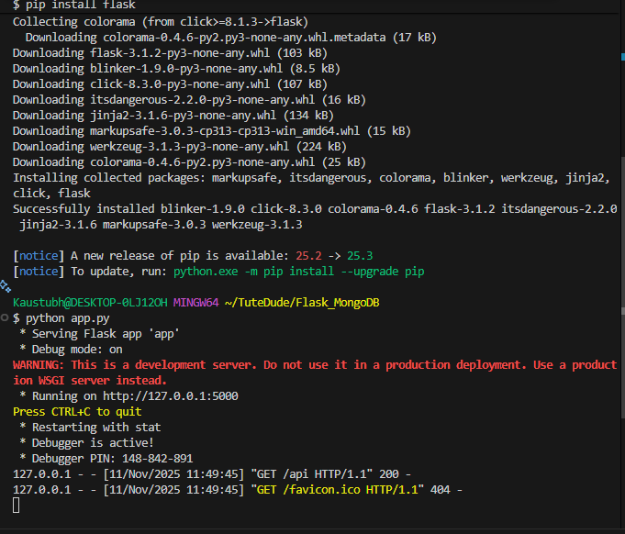
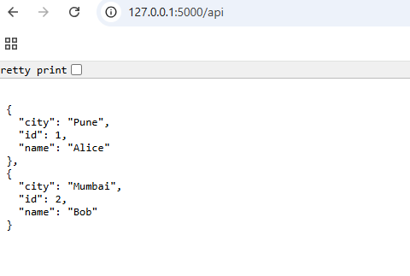
2️⃣ Flask Form with MongoDB Atlas Integration
Task:
Create a Flask app with a form that submits data to MongoDB Atlas and displays success or error messages accordingly.

Commands and Code:
mkdir flask_mongo_project
cd flask_mongo_project
pip install flask pymongo dnspython
# app.py
from flask import Flask, render_template, request
from pymongo import MongoClient

app = Flask(__name__)

# Replace <your_connection_string> with your MongoDB Atlas URI
client = MongoClient("<your_connection_string>")
db = client["student_db"]
collection = db["student_data"]

@app.route('/')
def index():
return render_template('form.html')

@app.route('/submit', methods=['POST'])
def submit_data():
try:
name = request.form['name']
email = request.form['email']
data = {"name": name, "email": email}
collection.insert_one(data)
return render_template('success.html', message="Data submitted successfully!")
except Exception as e:
return render_template('form.html', error=str(e))

if __name__ == '__main__':
app.run(debug=True)

Templates:
form.html
<!DOCTYPE html>
<html>
<head>
<title>Submit Form</title>
</head>
<body>
<h2>Enter Student Details</h2>

{% if error %}
<p style="color:red;">Error: {{ error }}</p>
{% endif %}

<form method="POST" action="/submit">
<label>Name:</label>
<input type="text" name="name" required><br><br>
<label>Email:</label>
<input type="email" name="email" required><br><br>
<button type="submit">Submit</button>
</form>
</body>
</html>
success.html
<!DOCTYPE html>
<html>
<head>
<title>Success</title>
</head>
<body>
<h2>{{ message }}</h2>
</body>
</html>

Explanation:
- The app connects to MongoDB Atlas using the connection string.
- When a user submits the form, data is inserted into the MongoDB collection.
- On success, it redirects to a success page displaying “Data submitted successfully!”.
- If an error occurs (e.g., wrong URI or DB issue), the error message appears on the same page (no redirection).

Screenshots:
📸 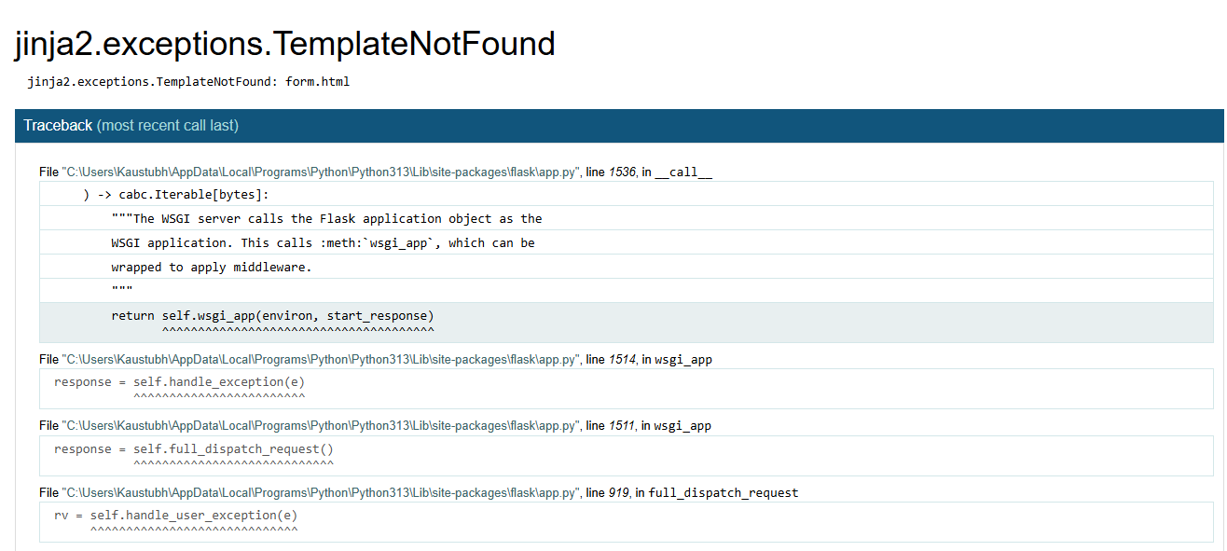
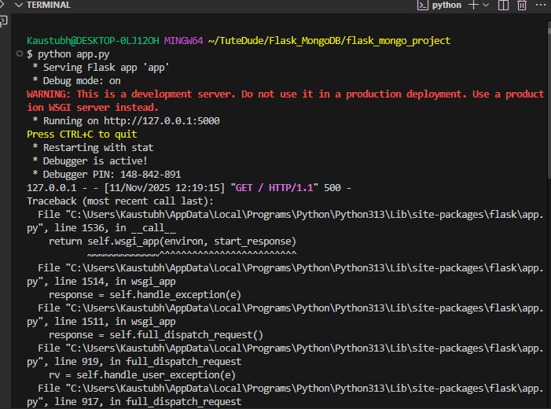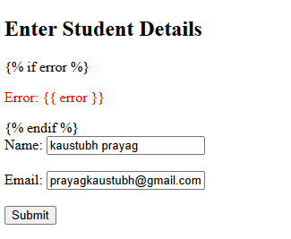
Submission
GitHub Repository Link: https://github.com/prayagkaustubh/TuteDude_Assignments.git

